**Experiment No.8**

**Aim:** To develop a **GUI-based Smart Attendance System** using **Java Swing** and **SQL Server**, which allows users to view student details, mark attendance, and generate attendance reports through an interactive graphical interface.

### **Theory:**

A **Graphical User Interface (GUI)** allows users to interact with applications visually using buttons, tables, and forms instead of text commands.

In this experiment, we created a **Smart Attendance System** with the following components:

1. **Frontend: Java Swing**
   * Designed GUI with buttons such as **Show Students**, **Mark Present**, and **Show Report**.
   * Displays database records using JTable and allows interaction with data.
2. **Backend: SQL Server**
   * Stores **Student** and **Attendance** details.
   * Performs database operations like **SELECT**, **INSERT**, and **JOIN**.
3. **Database Connectivity: JDBC Driver**
   * Uses Microsoft JDBC driver for connection between Java and SQL Server.
   * Executes SQL queries and retrieves results dynamically.

This system demonstrates how GUI and databases integrate to automate attendance management efficiently.

**GUI Screemshot:**

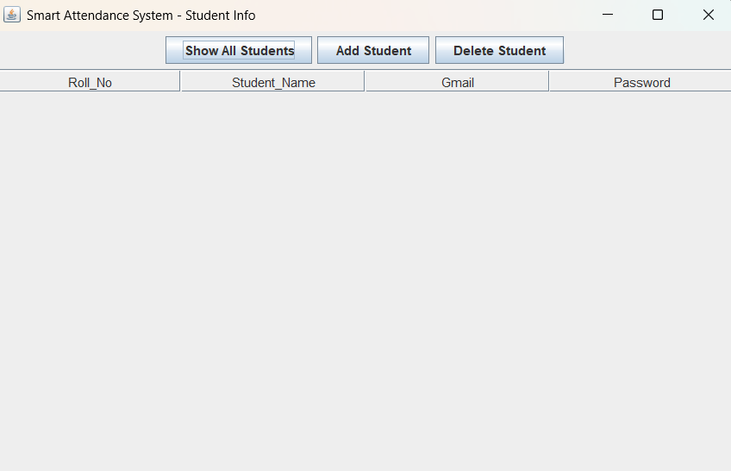

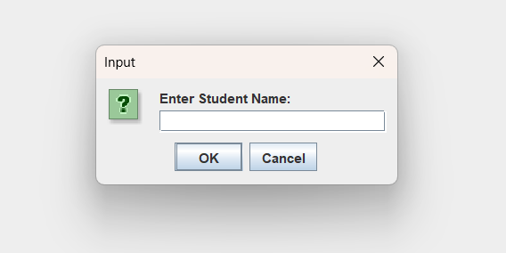

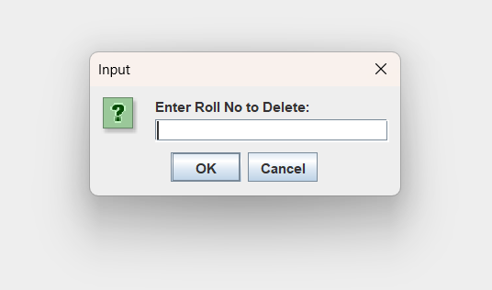

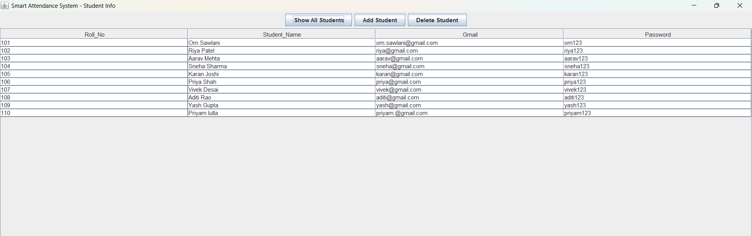

**Database Screenshot:**

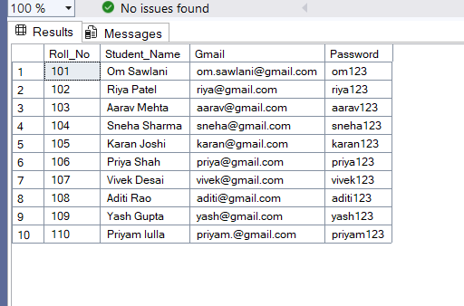

### **Conclusion:**

This experiment helped us understand:

1. How to connect **Java applications with SQL Server** using JDBC.
2. How to perform CRUD operations from a GUI.
3. How to design a simple desktop interface using **Java Swing**.
4. How to automate attendance recording and reporting.